Special Airworthiness Certificate
شهادة صلاحية خاصة للطيران
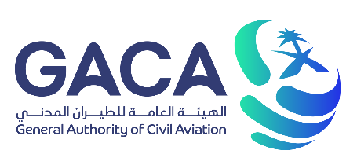 |  | KINGDOM OF SAUDI ARABIA  GENERAL AUTHORITY OF CIVIL AVIATION |  |  |  | 
Registration Mark  Click or tap here to enter text. |  |  |  | Manufacturer and Manufacturer's  Designation of Aircraft  Click or tap here to enter text.
Aircraft Serial No.  Click or tap here to enter text. |  |  | Category  Click or tap here to enter text. |  | purpose  Click or tap here to enter text.
Authority and Basis of Issuance
Issued pursuant to the Royal Decree No. M-44 dated 18 Rajab1426H (23 Aug 2005) and the Kingdom of Saudi Arabia Civil Aviation Regulations. this Airworthiness Certificate certifies that as of the date of issuance the aircraft to which issued has been inspected and found to be in condition for safe operation and meets all applicable related GACARs.
Operating Limitations
Click or tap here to enter text.
Terms and conditions
The aircraft does not meet the requirements of the applicable comprehensive and detailed airworthiness codes as provided by Annex 8 to the Convention on International Civil Aviation. No person may operate the aircraft:
(1) except in accordance with the applicable GACAR and in accordance with conditions and limitations which may be prescribed by the President as part of this certificate; and
(2) over any foreign country without the special permission of that country.
Date of Issuance  Click or tap here to enter text. |  |  |  |  |  |  | Date of Expiry  Click or tap here to enter text.
Date of Issuance  Click or tap here to enter text. | Capt. Sulaiman Saleh Almuhaimedi  EVP of Aviation Safety and Environmental Sustainability |  |  |  |  |  | Date of Expiry  Click or tap here to enter text.
Any Alteration, Reproduction, or Misuse of This Certificate May Be Punishable By A Fine or Imprisonment, This Certificate Must Be Displayed In The Aircraft In Accordance With Applicable Gaca Regulations.
GACA-AVSES-AIR-F069, Rev: 2

